Bài 1:

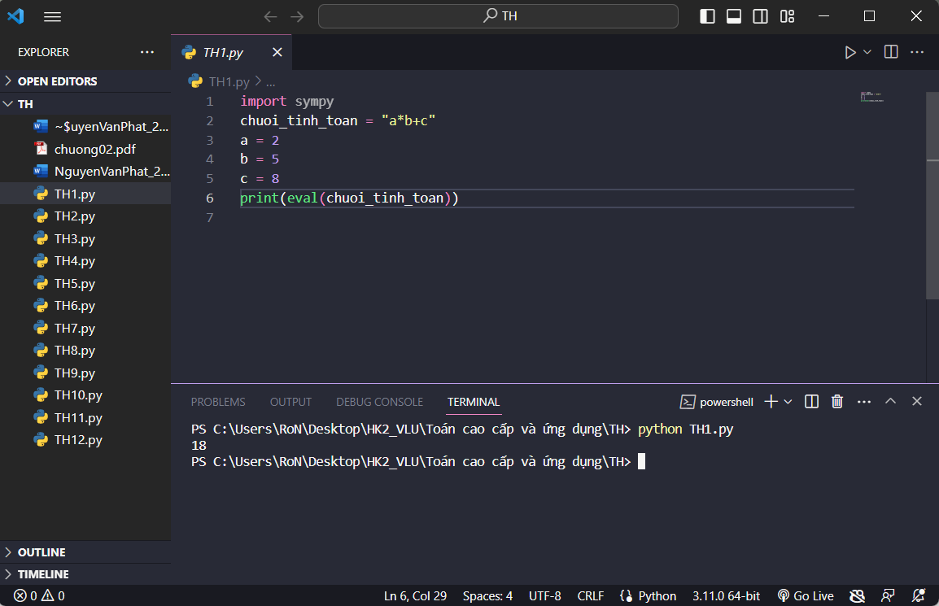

Bài 2:

Bài 3:

Bài 4:

Bài 5:

Bài 6:

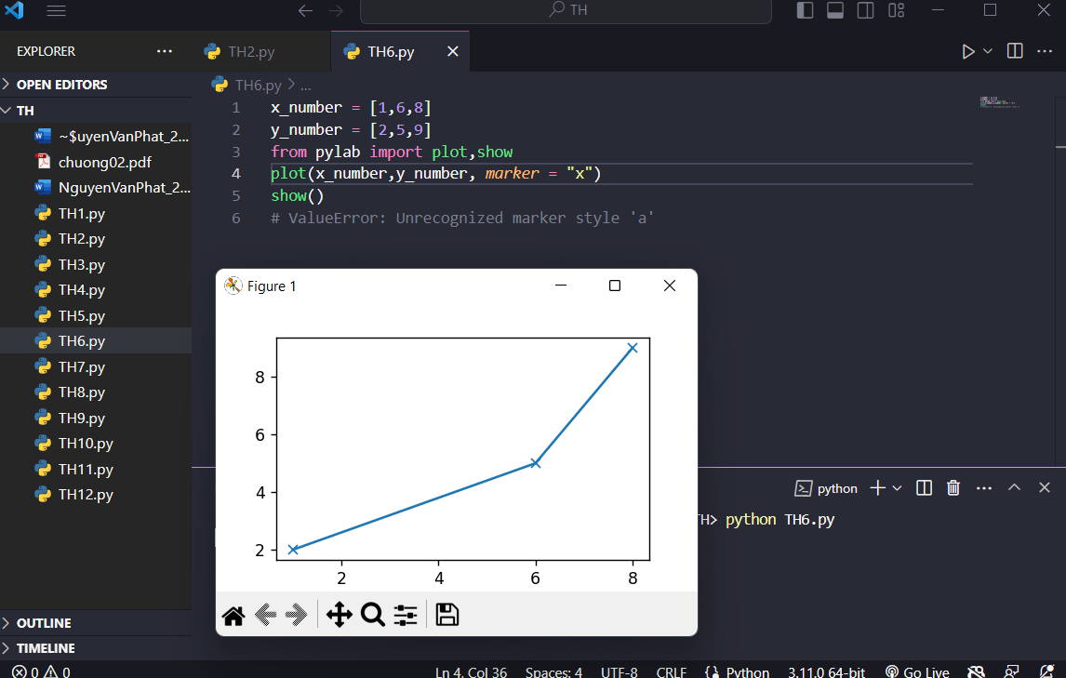

Bài 7:

Bài 8:

Bài 9:

Bài 10:

Bài 11:

Bài 12:

